Useful Information

Demarest Advogados
Av. Pedroso de Morais, No. 1201 - Pinheiros, São Paulo – SP
Parking lot’s entry through Rua Coropé, No. 88 - Pinheiros, São Paulo - SP
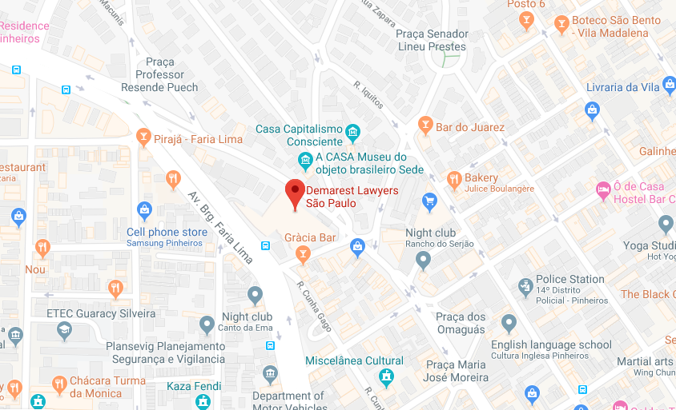

Lunch and dinner options
Gardênia: Praça dos Omaguás, 110 – 250m
Restaurante Santinho Tomie Ohtake: Rua Coropé, 88 – Piso TF
Aoyama (Japanese cuisine): Rua Morás, 40 – 100m
Theodora Sushi (Japanese cuisine): R. Diogo Moreira, 138 – 1,2km
NB Steak: Av. Brigadeiro Faria Lima, 140 – 200m
Busger (hamburger): Rua Heitor Penteado, 153 – 1,7 km
Buzina Burgers: Rua Cunha Gago, 590 – 350m

Lanchonete da Cidade (hamburger): Rua Coropé, 51 – 50m
Vinil Burger: Rua Padre Carvalho, 18 – 200m
Bar do Juarez (Brazilian food): Rua Dep. Lacerda Franco, 642 – 200m
NOU (contemporary): Rua Ferreira de Araujo, 419 – 400m
Pirajá (Brazilian food): Av. Brigadeiro Faria Lima, 64 – 200m
Burger King (fast-food): Av. Pedroso de Morais, 1556 – 300m

Contact
In case you need any further assistance, please contact us at mootcam@ccbc.org.br.

